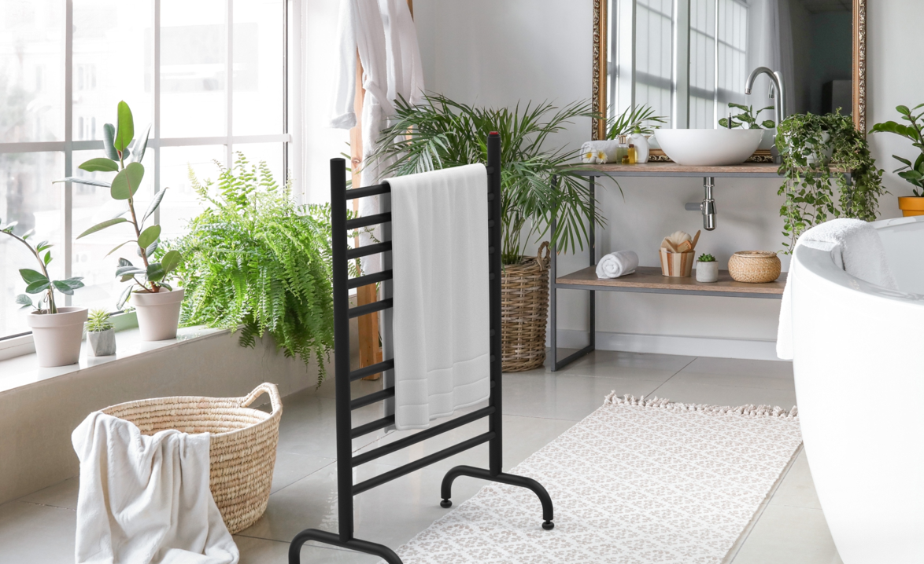

For Immediate Release
Amba® Products Adds Two New Finishes Their Most Popular Collections
(ATLANTA) – September 1, 2021 – To accommodate the growing demand for modern finishes within interior design, Amba Products, the country’s premier distributor of heated towel rack systems, has introduced two new color options to its Solo and Radiant product line ups.
Amba’s Solo free-standing models are now available in matte black. In addition, the Radiant Hardwired Straight and the Radiant Small are available in polished gold. The newest finish offerings provide homeowners and interior designers with more color options to better fit various styles of décor.
Peter Manidis, marketing manager for Amba, stated, “For many years stainless steel and brushed steel finishes dominated interior design. However, over the last few years, there has been a shift within the industry, paving the way for less conventional finishes like matte black and polished gold.”
Previously, stainless steel and brushed steel were the only finish options offered within the Solo collection. After the success of the matte black color in other models, Amba decided to introduce the finish in the Solo model, one of its bestselling product lines.
The polished gold finish is only available in select models within the Radiant Collection. It is an entirely new finish offering for Amba Products, and the company will use its launch to determine whether to expand the option to other collections.
Amba Products, headquartered in Atlanta, distributes more than 150 affordable heated towel rack models in both mounted and free-standing profiles. Each corrosion-resistant high-grade 304 steel rack is 100-percent recyclable and packaged with fully recyclable materials. Heated towel racks are stylish and functional additions to any bathroom, laundry room, or mudroom. They are energy-efficient and keep towels fresh while decreasing trips to the laundry and reducing airborne mold.
###

About Amba® Products
Amba Products was established in 2004 with a clear goal in mind – to make the heated towel rack a must-have item for every bathroom in North America. While Europeans have been drying and warming their towels on heated towel racks for decades, most Americans have no experience with them. For many Americans, heated towel racks are view as overpriced, not widely available, and seen only in the homes of the rich. A perception has persisted that they are a luxury item out of reach for most American families.
Amba Products changed this view and is proud to be one of the first companies in the U.S. to introduce consumers to affordable, stylish heated towel racks made of high-quality stainless steel. Initially supplying a handful of clients with top-grade heated towel racks, Amba now proudly boasts the largest variety of products and serves more than 200 retailers throughout the United States, Canada, Mexico, and the Caribbean. Visit www.ambaproducts.com to learn more.

Link to High Resolution Images
https://www.dropbox.com/sh/hv7a5g423wh8ute/AAB0YaeKMQw-rhAYRTX2ixwra?dl=0

